Architecture Research



Jeroen Koeter

S3-DB01

Table of contents

What is the microservice architecture? 3

What is an monolithic application? 4

List of sources 5

# What is the microservice architecture?

The microservice architecture is an architecture in which you’ll divide all the different parts of an application into its own. As you can see in the picture below, the client talks to an API which talks to the different micro services. These services all have their own function. The great thing about this architecture is that you can easily add and remove services. So your program will be very flexible when it comes to change.

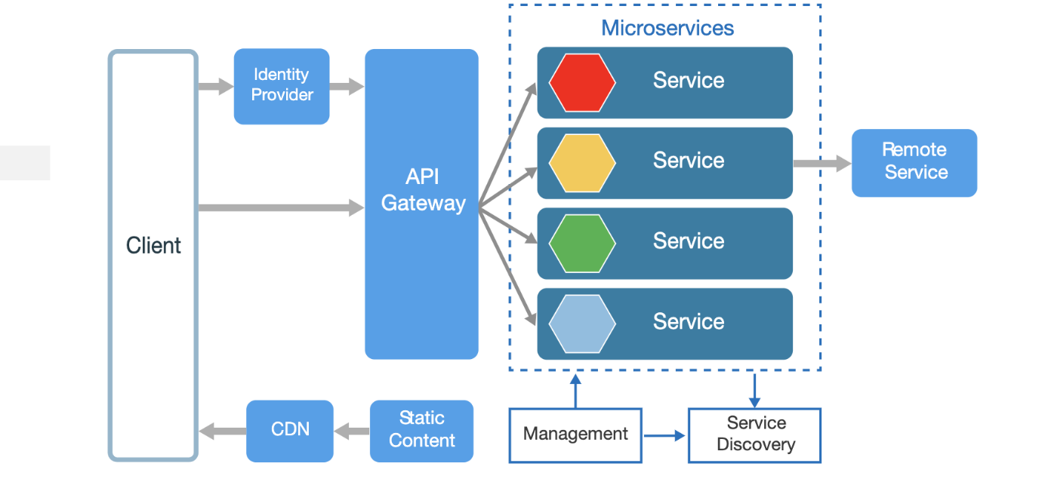

What are the pros of the microservice architecture?

* Your application can scale better when you use the microservice architecture. The reason your application is more scalable is because you can scale each service independently instead of having to edit your entire application.
* Micro services are very versatile, you are no longer stuck with 1 language for instance. This makes working in a team made up of different skillsets very easy.
* You can easily improve a single functionality without having to fear for breaking the rest of the application. This also greatly increases the maintainability of your application.
* You can easily take advantage of functionality that third party developers have already invented.

What are the cos of the microservice architecture?

* Its harder to write test for you entire application, this is harder because every service is independent of each other. So you can easily test your individual services, but its harder to test everything together.
* Using microservices has a steep learning curve for new developers.

# What is an monolithic application?

In an monolithic architecture all your code will be in an single big unit. This does make it easier to develop, but it’ll make long time support a pain. This because you can’t scale independent components of an monolithic application. Monolithic architectures have been the go to for years and as a result of that there are a lot of well working application with an monolithic architecture. As you can see in the image below, an monolithic architecture has one big clump of business logic. You can have more layers in an monolithic architecture, but they’ll always stay in the same system unlike the microservice architecture where every function is its own service.

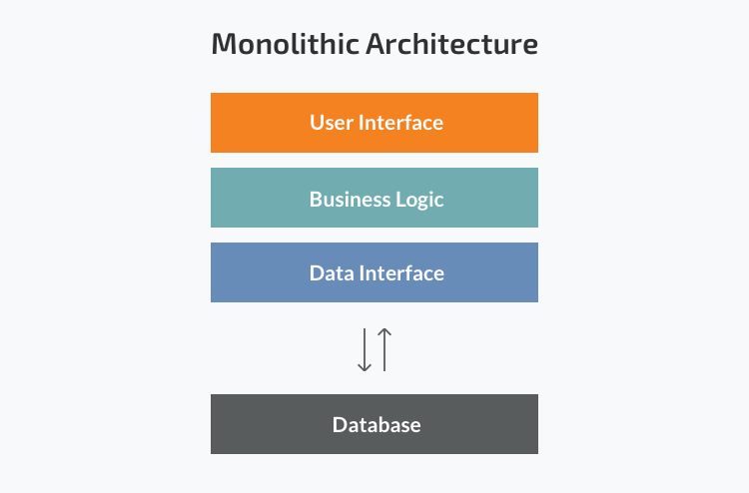

What are the pros of an monolithic architecture?

* Starting a new project is quite easy, also development is easier in the beginning.
* A monolithic architecture has an easy learning curve compared to the microservice architecture.
* Its easier to write tests for your application as a whole.
* Deployment is very easy. Deployment with an monolithic architecture is basically copy pasting everything on the server.

What are the cons of an monolithic architecture?

* Your code will be harder to understand for someone who hasn’t worked on it. The reason for this is that you have everything in one big clump.
* You cannot scale individual parts of your application. This means that when one part of you application needs to scale everything will have to restart and will be scaled.
* Its hard to change to an new technology or framework, this is because everything in your code is so closely linked to each other.

# List of sources

* <https://techbeacon.com/app-dev-testing/top-5-software-architecture-patterns-how-make-right-choice>
* <https://raygun.com/blog/what-are-microservices/>
* <https://medium.com/@goodrebels/to-go-or-not-to-go-micro-the-pros-and-cons-of-microservices-7967418ff06>
* <https://searchapparchitecture.techtarget.com/tip/Pros-and-cons-of-monolithic-vs-microservices-architecture>